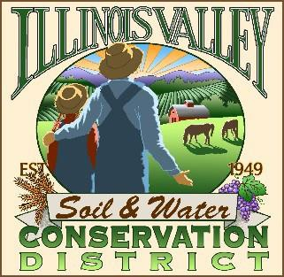
Illinois Valley Soil and Water Conservation District
331 E Cottage Park Dr Suite 1B - P.O. Box 352
Cave Junction, OR 97523 Phone: 541-592-3731

Monthly Board Meeting Agenda April 25, 2024- SWCD Office/ZOOM

- 6:00 PM: Call to Order
- 6:05 PM: Acceptance of Minutes
- 6:10 PM: Acceptance of Financial Reports
- 6:15 PM: Old Business
  - Reminder- election materials available on ODA Website
  - Planning for Hanby Block Party
  - Committee Formation for 75th Anniversary Celebration

- 6:40 PM: New Business
  - The Upper Illinois River Watershed Postfire Restoration Project is now up for bid on OregonBuys.
The sealed proposals will be opened on 4/22 at 5:00pm.
John will be mailing/emailing these documents to the Board of Directors at this time.
The directors will act as the Local Contract Review Board for this project. Please come to this month's board meeting ready to discuss and vote on which contractor to award the project to.
The contract must go to the lowest responsible bidder.
- 7:00 PM: Staff and Partnering Agency Reports
  - John’s report
  - Arlyse’s Report
  - Partnering Agency Reports
- 7:20 PM Public comments
- 7:30 PM: Adjourn

