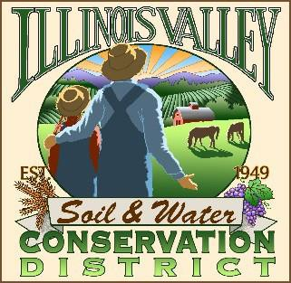
Illinois Valley Soil and Water Conservation District
331 E Cottage Park Dr Suite 1B - P.O. Box 352
Cave Junction, OR 97523 Phone: 541-592-3731

Monthly Board Meeting Agenda May 26, 2022- SWCD Office/ZOOM

- 7:10 PM: Call to Order
- 7:15PM: Acceptance of Minutes
- 7:18PM: Acceptance of Financial Reports
- 7:20 PM: Old Business
  - Hiring update- Conservation Program Manager
- 7:40 PM: New Business
  - Inland Rogue Ag Water Area Plan Review (Action item)
  - Employee Handbook/Personnel Policy Manual update
  - Farmer’s Market (Action Item)

- 7:50 PM: Staff and Partnering Agency Reports
  - Kevin’s report
  - Cheryl’s report
  - Arlyse’s Report

- Public comments

- 8:45 PM: Adjourn

