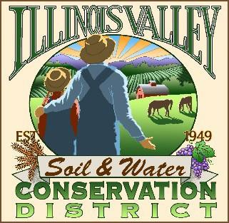
Illinois Valley Soil and Water Conservation District
331 E Cottage Park Dr Suite 1B - P.O. Box 352
Cave Junction, OR 97523 Phone: 541-592-3731

Monthly Board Meeting Agenda July 27, 2023- SWCD Office/ZOOM

- 6:00 PM: Call to Order
- Q&A session with Dan Van Dyke (Rogue District Fish Biologist with ODFW)
- 6:30 PM: Acceptance of Minutes
- 6:35 PM: Acceptance of Financial Reports
- 6:40 PM: Old Business
  - Water Quality Monitoring Report
  - Draft Contract Review *Action*

- 7:00 PM: New Business

  - To Be Announced

- 7:10 PM: Staff and Partnering Agency Reports
  - John’s report
  - Cheryl’s report
  - Arlyse’s Report

- 7:20 PM Public comments
- 7:25 Partnering Agency Reports/Comments
- 7:30 PM: Adjourn

