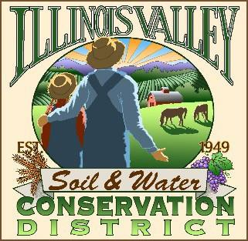

**Illinois Valley Soil and Water Conservation District**

331 E Cottage Park Dr Suite 1B - P.O. Box 352

Cave Junction, OR 97523 Phone: 541-592-3731

**Annual Meeting Agenda February 27, 2025- *IV Community Library/ZOOM***

IVSWCD is inviting you to a scheduled Zoom meeting. The physical location will be 209 W Palmer St, Cave Junction.

Topic: Illinois Valley Soil & Water Conservation District Meeting

Time: February 27th, 2025 - 6:00 pm Join Zoom Meeting:

<https://us06web.zoom.us/j/95435099861?pwd=UXNsUEgyT200Ym9ZUVhEa1UvbnFUdz09>

***Meeting ID: 954 3509 9861***

***Passcode: Conserve***

1. **6:00 PM: Call to Order**
2. **6:01 PM: Acceptance of Minutes**
3. **6:05 PM: Acceptance of Financial Reports**
4. **6:10 PM: Old Business**

**a. Schedule 75th Anniversary Planning meeting**

1. **6:15 PM: New Business**
   1. **List of director skills/equipment**
   2. **Connect Conference *action\***
   3. **Special Presentation**

**6:25 PM: Staff and Partnering Agency Reports**

* 1. **John’s report**
  2. **Arlyse’s Report**
  3. **Partnering Agency Reports**

1. **6:30 PM - Program**
2. **7:00 Public comments**
3. **7:15 Adjournment**