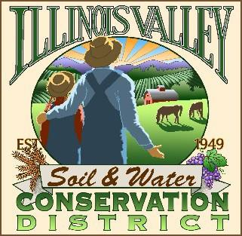
Illinois Valley Soil and Water Conservation District
331 E Cottage Park Dr Suite 1B - P.O. Box 352
Cave Junction, OR 97523 Phone: 541-592-3731

Annual Meeting Agenda December 15, 2022- SWCD Office/ZOOM

- 6:00 PM: Call to Order
- 6:01PM: Acceptance of Minutes
- 6: 05 PM: Acceptance of Financial Reports
- 6:10 PM: Old Business
  - T.B.A.
- 6:15 PM: New Business
  - T.B.A
- 6:20 PM: Staff and Partnering Agency Reports
  - John’s report
  - Cheryl’s report
  - Arlyse’s Report

- 6:25 Public comments

- 6:30 PM: Adjournment followed by short IVWC meeting, refreshments and white elephant gift exchange

