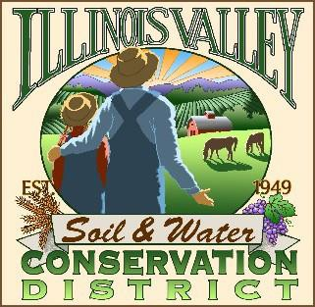
Illinois Valley Soil and Water Conservation District
331 E Cottage Park Dr Suite 1B - P.O. Box 352
Cave Junction, OR 97523 Phone: 541-592-3731

Monthly Board Meeting Agenda January 27th, 2021- SWCD Office/ZOOM

- 7:10 PM: Call to Order
- 7:15PM: Acceptance of Minutes
- 7:18PM: Acceptance of Financial Reports
- 7:20 PM: Old Business
  - Hiring update- Engagement Coordinator
  - 7:40 PM: New Business
  - Upcoming election-discussion
  - Reconvene budget committee for retirement plan
  - Potential new position

- 7:50 PM: Staff and Partnering Agency Reports
  - Tracey’s report
  - Arlyse’s Report

- 8:30 PM: Public Comments

- 8:45 PM: Adjourn

