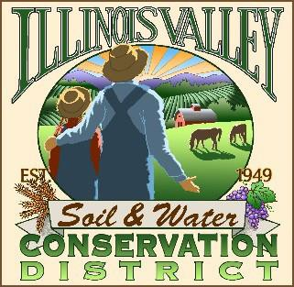
Illinois Valley Soil and Water Conservation District
331 E Cottage Park Dr Suite 1B - P.O. Box 352
Cave Junction, OR 97523 Phone: 541-592-3731

Monthly Board Meeting Agenda June 23,2022- SWCD Office/ZOOM

- 6:00 PM: Call to Order
- 6:15PM: Acceptance of Minutes
- 6:18PM: Acceptance of Financial Reports
- 6:20 PM: Old Business
  - Hiring update- Conservation Program Manager-Action
  - Inland Rogue Ag Water Quality Mgmt Plan Review- Report (Webb, Nelsen)
  - Farmer’s Market
  - Crooks Creek Update
  - Goff Project Completion Update
  - White Ditch Update
- 6:50 PM: New Business
  - Payroll options quote

- 7:00 PM: Staff and Partnering Agency Reports
  - Kevin’s report
  - Cheryl’s report
  - Arlyse’s Report

- 7:10 Public comments

- 7:15 PM: Adjourn

