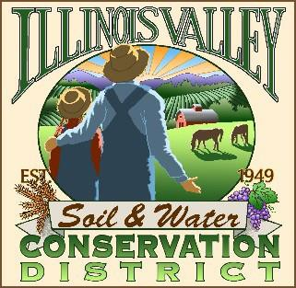
Illinois Valley Soil and Water Conservation District
331 E Cottage Park Dr Suite 1B - P.O. Box 352
Cave Junction, OR 97523 Phone: 541-592-3731

Monthly Board Meeting Agenda March 28, 2024- SWCD Office/ZOOM

- 6:00 PM: Call to Order
- 6:05 PM: Acceptance of Minutes
- 6:10 PM: Acceptance of Financial Reports
- 6:40 PM: Old Business
  - Records Retention
  - Lending and Risk Management

- 6:50 PM: New Business
  - IVSWCD 75th Anniversary planning
  - Hanby Block Party May 29th
  - Access to office for WQM lead
  - Strategic Implementation Area for 2025?

- 7:10 PM: Staff and Partnering Agency Reports
  - John’s report
  - Arlyse’s Report
  - Partnering Agency Reports

- 7:20 PM Public comments

- 7:30 PM: Adjourn

